# Start Command Line

Press the keys Windows + R

Type cmd

Ein Bild, das Text, Screenshot, Software, Betriebssystem enthält.

A new window appears:

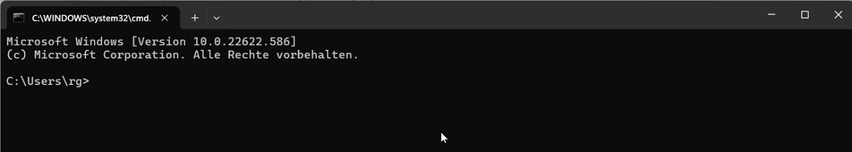

# Create folder for development environment.

Enter the following commands:

C:

cd \

mkdir \Coding4Beginner

cd \Coding4Beginner

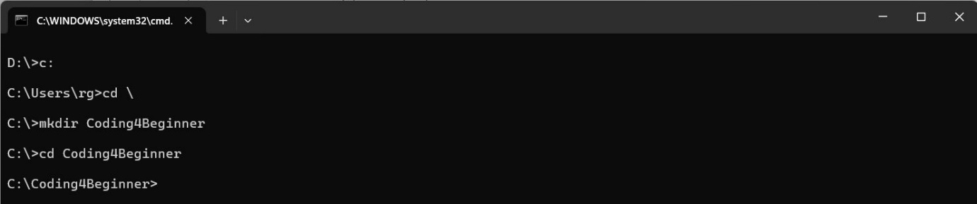

Enter the following command:

git clone <https://github.com/coding4beginner/Playground>

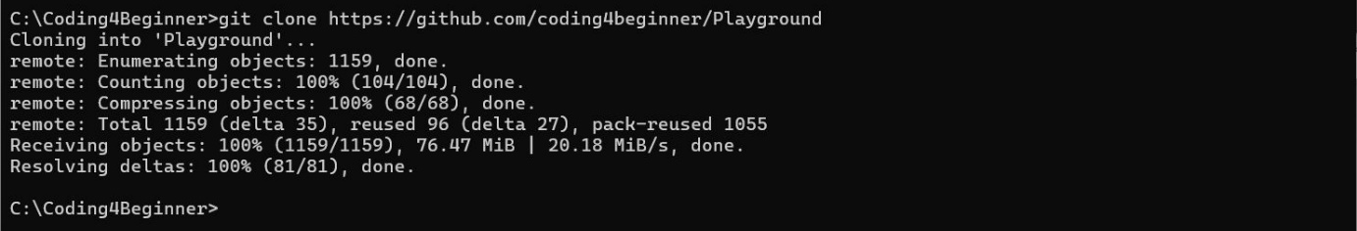

Change to new folder and view content.

cd Playground

dir

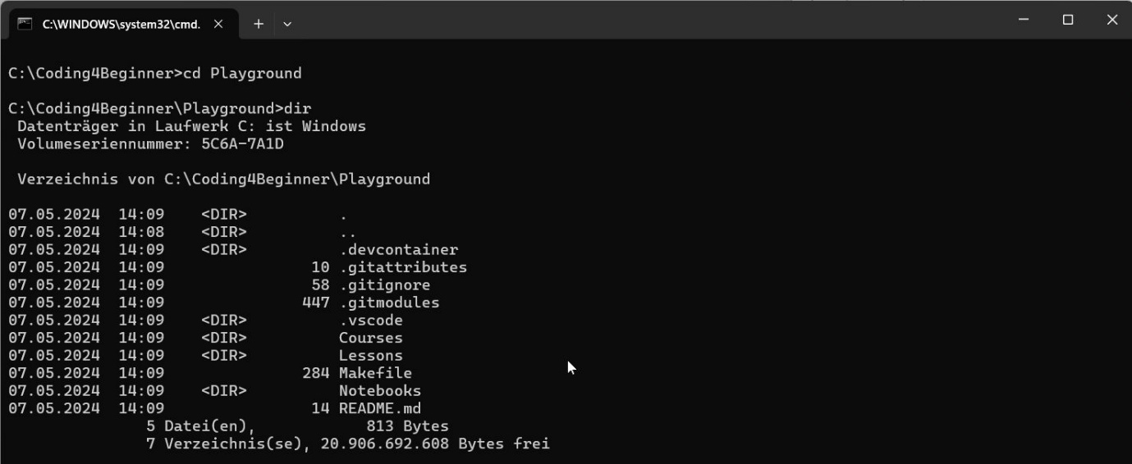

# Start VS Code

Press the keys CTRL + ESC or open the program menu.

Ein Bild, das Text, Screenshot, Schrift, Logo enthält.

IN the upper input box type “Visual”

Beneath this line, the application Visual Studio Code – Insiders should appear.

Click on the icon

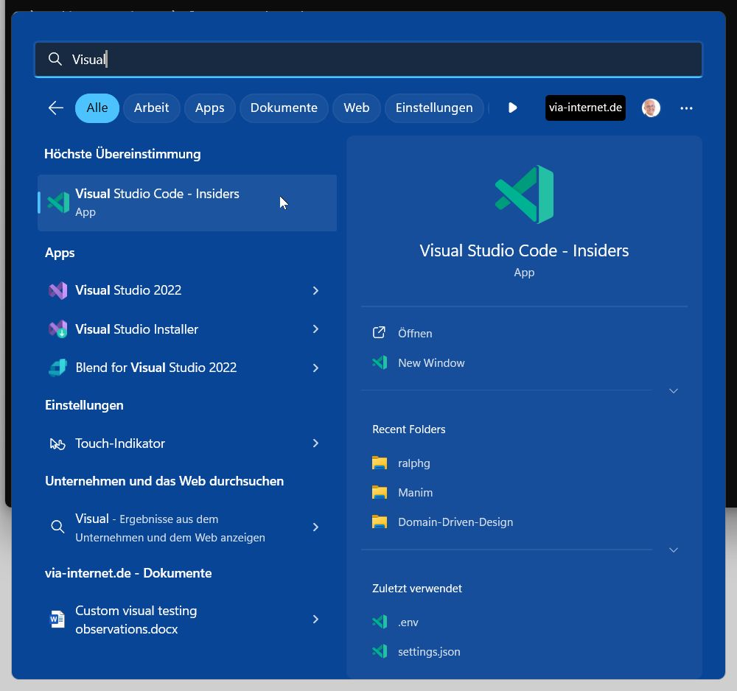

Visual Studio Code should open:

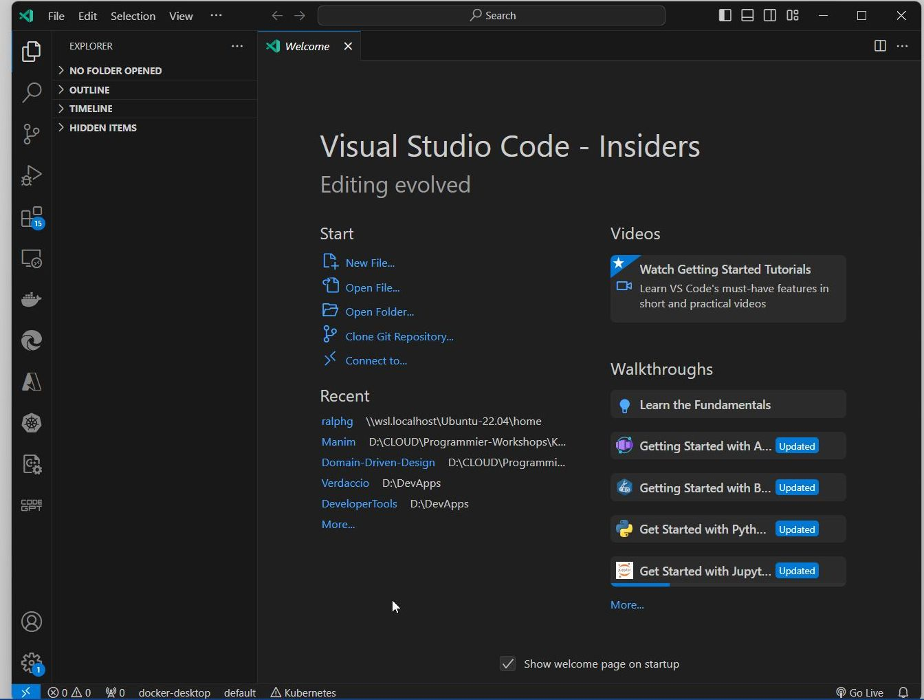

On the lower left, if you see a blue badge with a number, you could update to a new version.

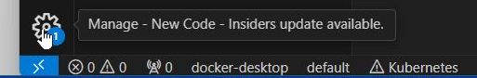

Click on the icon and select Restart to Update

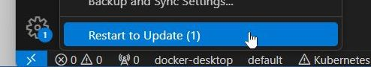

The application should be closed and reopened after a while with the new version information.

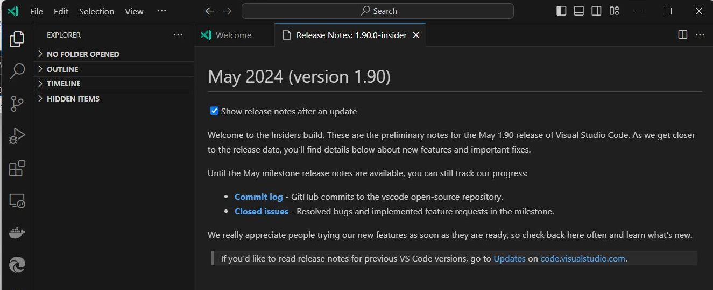

# Open the Repository

Open the created folder.

Select File / Open Folder

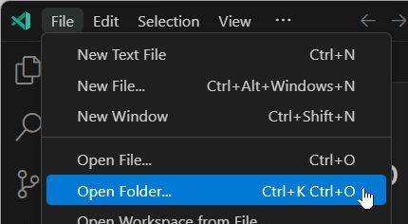

Select the created folder C:\Coding4Beginner

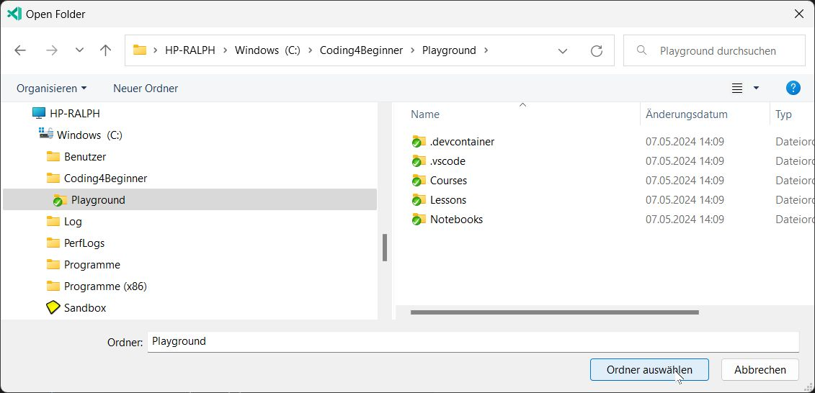

After opening the folder and some time, you see two popups on the lower right side:

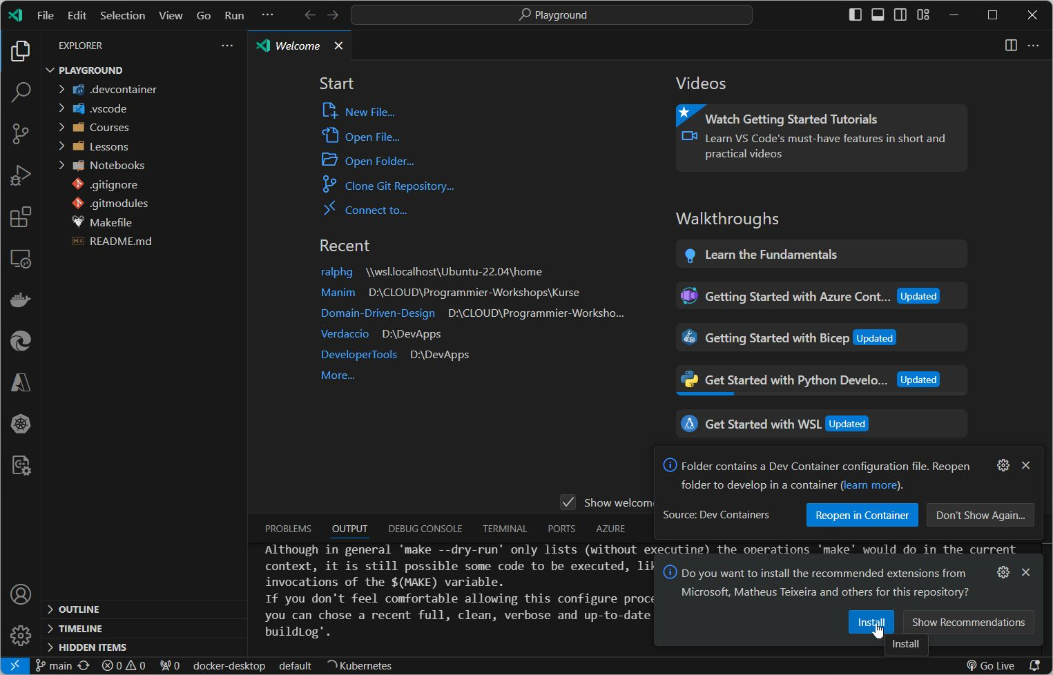

## Install recommended extensions

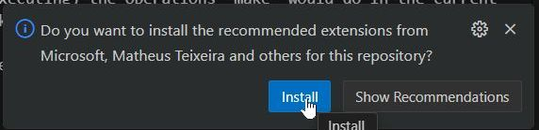

Click on Install

After a few seconds, restart die application.

* Either by close the app and open it again
* Or be typing CTRL-SHIT-P and entering Reload in the search field.  
  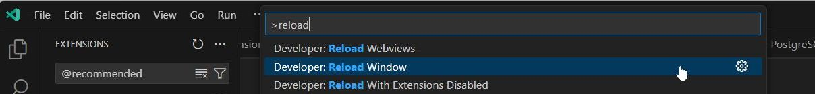  
  Click on Developer: Reload Window

The application should be closed and reopened after a while.

Then, on the popup, click on Reopen in Container

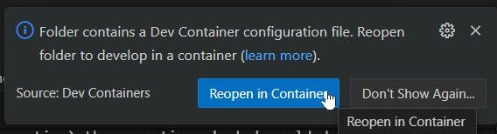

The application will start with some installation steps, which you can follow by clicking on show log

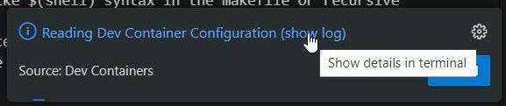

In the log, you will see the steps, which are executed to install and prepare our development environment.

Technically:

We are installing a Linux Distribution (Ubuntu) and install all the required packages (Python, Django, NodeJS, JavaScript, Jupiter) we need for our exercises.

After a long time (maybe more than 20 Minutes, depending on your internet speed), the installation is finished.

You should see something like this, especially on the upper left under EXPLORER the folder name

WORKSPACE [DEV CONTAINER: …]

Ein Bild, das Text, Screenshot, Schrift, Software enthält.

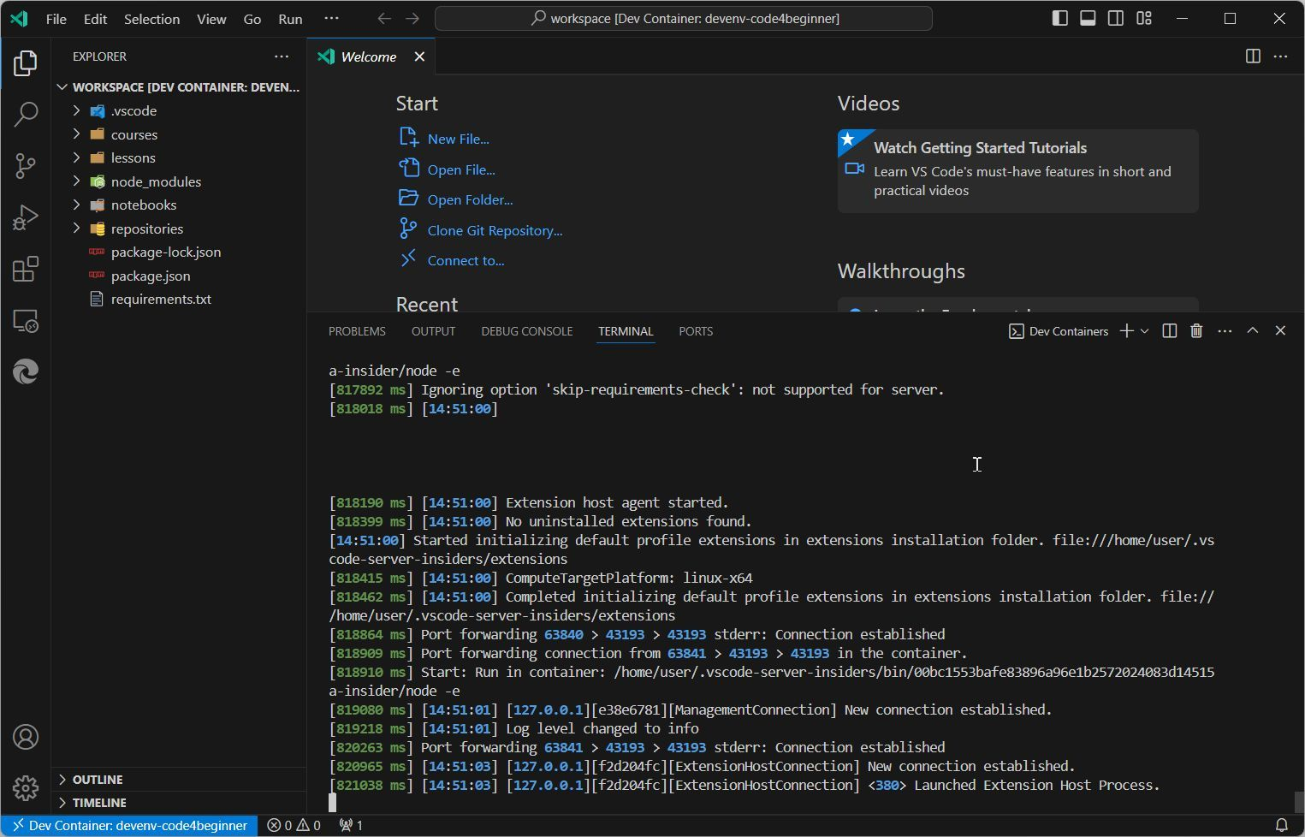

And, again, you should the pop up for installing recommended extensions,

So, click on Install

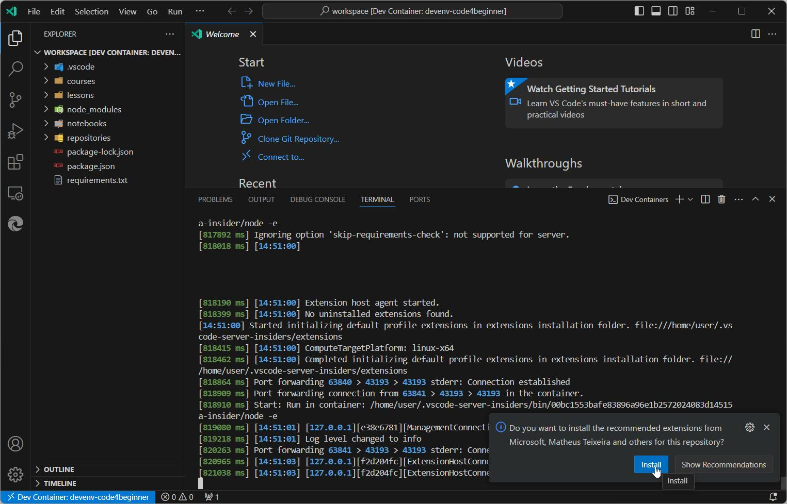

After this, you should see multiple windows with a register for each installed extension

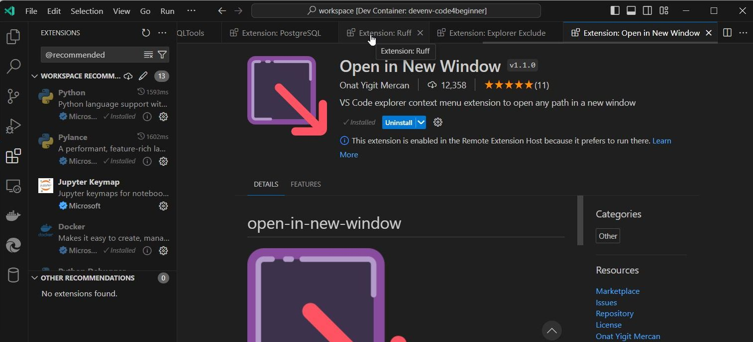

Right-Click on a header of a register and select Close All

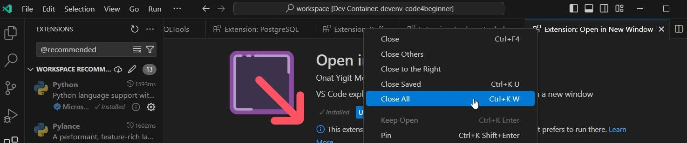

# Check Development Environment

## Check, if a required extension is installed.

Click on Extensions:

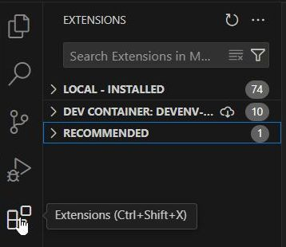

In the upper textbox insert live server

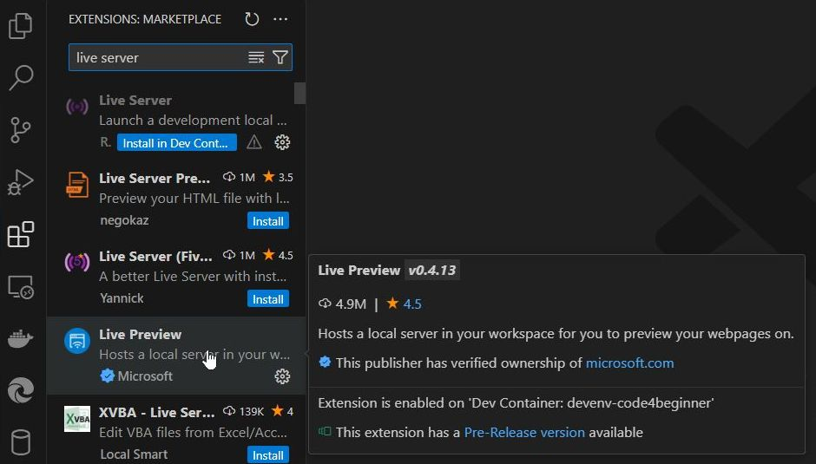

If you find the extension with a configuration icon, everything is good.

Ein Bild, das Text, Screenshot, Schrift enthält.

If you see an Install Button, then click on Install, Install Pre-Release or Install in Dev-Container

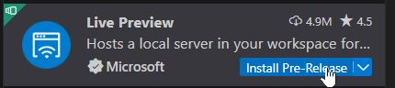

Open the Explorer View

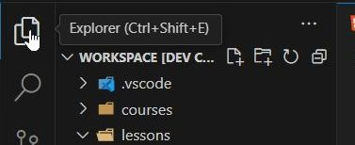

## Preview a file

Navigation to the file lessons/Week01/solutions/01.html

Right-Click on 01.html and select Show Preview

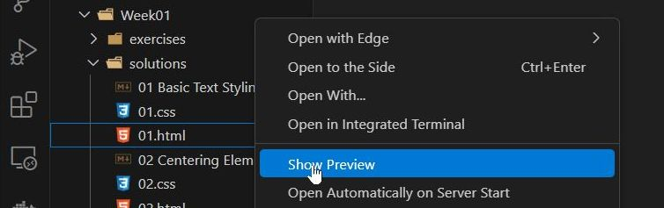

Final Result should be

